

**Practical File**

**Of**

**Introduction to Computer Networks**

**22CS008**

**Submitted By Submitted To**

Name - Moksh Goyal Dr. Htet Ne Oo

Roll No - 2210991933

Group - G(9)

**Department of Computer Science & Engineering**

**Chitkara University Institute of Engineering & Technology, Rajpura, Punjab.**

# Index

|  |  |  |  |
| --- | --- | --- | --- |
| **S. No.** | **Title of Practical** | **Page No.** | **Signature** |
| 1 | Introduction of Cables, Network devices: Hub, Switches, Router etc. | 3-5 |  |
| 2 | Installation and Introduction to Packet Tracer | 6-9 |  |
| 3 | Simulation of Network Devices (HUB, Switches, Router) and connect more than two computers using Switch to Topologies like Star, Mesh, Ring, BUS, Hybrid etc… | 10-13 |  |
| 4 | Basic commands of Routers: hostname, password, Show Run, Show IP int brief, Assigning IP addresses to interfaces | 14-20 |  |
| 5 | To do peer to peer connectivity, assign the IP address and share the resources | 21-22 |  |
| 6 | Subnetting with Class A, B, C with different IP addresses |  |  |
| 7 | Subnetting of Class A, B and C using FLSM |  |  |
| 8 | Subnetting of Class A, B and C using VLSM |  |  |
| 9 | To Perform Static Routing, Default Routing by using  2 and 3 routers |  |  |
| 10 | To Perform Dynamic Routing using RIP  (RIP-V1 and RIP-V2) |  |  |
| 11 | To Perform Dynamic Routing using EIGRP |  |  |
| 12 | To Perform Dynamic Routing using OSPF with  Single area concept and Multiple Area Concept |  |  |
| 13 | To Create and Apply ACL: Standard and Extended |  |  |
| 14 | Creating and Managing Communication through VLAN |  |  |
| 15 | To Apply NAT (Network Address Translation): Static |  |  |

## Experiment No. 1

**Aim: - Introduction of Cables, Network devices: Hub, Switches, Router etc.**

**Solution: -**To connect two or more computers or networking devices in a network, network cables are used. There are three types of network cables; coaxial, twisted-pair, and fiber - optic.

**Coaxial cable** This cable contains a conductor, insulator, braiding, and sheath. The sheath covers the braiding, the braiding covers the insulation, and the insulation covers the conductor.

The following image shows these components.

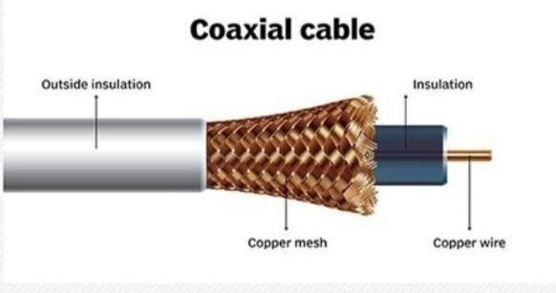

**Twisted-pair cables** The twisted-pair cable was primarily developed for computer networks. This cable is also known as Ethernet cable. Almost all modern LAN computer networks use this cable. This cable consists of colorcoded pairs of insulated copper wires. Every two wires are twisted around each other to form pair. Usually, there are four pairs. Each pair has one solid colour and one stripped colour wire. Solid colours are blue, brown ,green, and orange. In stripped colour, the solid colour is mixed with the white colour.

**Fiber optic cable** This cable consists of a core, cladding, buffer, and jacket. The core is made from thin strands of glass or plastic that can carry data over a long distance. The core is wrapped in the cladding; the cladding is wrapped in the buffer, and the buffer is wrapped in the jacket.

* Core carries the data signals in the form of light.
* Cladding reflects light back to the core.
* Buffer protects the light from leaking.
* The jacket protects the cable from physical damage.

Fiber optic cable is completely immune to EMI and RFI. This cable can transmit data over a long distance at the highest speed. It can transmit data up to 40 kilometers at the speed of 100Gbps

### NETWORK DEVICES

1. **Hub** – A hub is basically a multiport repeater. A hub connects multiple wires coming from different branches, for example, the connector in star topology which connects different stations. Hubs cannot filter data, so data packets are sent to all connected devices. In other words, collision domain of all hosts connected through Hub remains one. Also, they do not have intelligence to find out best path for data packets which leads to inefficiencies and wastage. Types of Hub
   * Active Hub :- repeater as well as wiring center. These are used to extend maximum distance between nodes.
   * Passive Hub :- These are the hubs which collect wiring from nodes and power supply from active hub. These hubs relay signals onto the network without cleaning and boosting them and can’t be used to extend distance between nodes.
2. **Switch** – A switch is a multi port bridge with a buffer and a design that can boost its efficiency (large number of ports imply less traffic) and performance. Switch is data link layer device. Switch can perform error checking before forwarding data, that makes it very efficient as it does not forward packets that have errors and forward good packets selectively to correct port only. In other words, switch divides collision domain of hosts, but broadcast domain remains same.
3. **Routers –** A router is a device like a switch that routes data packets based on their IP addresses. Router is mainly a Network Layer device. Routers normally connect LANs and WANs together and have a dynamically updating routing table based on which they make decisions on routing the data packets.

Router divide broadcast domains of hosts connected through it. These are the hubs which have their own power supply and can clean , boost and relay the signal along the network. It serves both as a Your text here 1 Hub 1 Hub.

1. **Gateway** – A gateway, as the name suggests, is a passage to connect two networks together that may work upon different networking models. They basically works as the messenger agents that take data from one system, interpret it, and transfer it to another system. Gateways are also called protocol converters and can operate at any network layer. Gateways are generally more complex than switch or router.
2. **Brouter** – It is also known as bridging router is a device which combines features of both bridge and router. It can work either at data link layer or at network layer. Working as router, it is capable of routing packets across networks and working as bridge, it is capable of filtering local area network traffic. 6.Repeater – A repeater operates at the physical layer. Its job is to regenerate the signal over the same network before the signal becomes too weak or corrupted so as to extend the length to which the signal can be transmitted over the same network. An important point to be noted about repeaters is that they do not amplify the signal. When the signal becomes weak, they copy the signal bit by bit and regenerate it at the original strength. It is a 2 port device.

7. **Bridge** – A bridge operates at data link layer. A bridge is a repeater, with add on functionality of filtering content by reading the MAC addresses of source and destination. It is also used for interconnecting two LANs working on the same protocol. It has a single input and single output port, thus making it a 2 port device.

Types of Bridges

* Transparent Bridges :- These are the bridge in which the stations are completely unaware of the bridge’s existence i.e. whether or not a bridge is added or deleted from the network , reconfiguration of the stations is unnecessary. These bridges makes use of two processes i.e. bridge forwarding and bridge learning.

## Experiment No. 2

**Aim: - Installation and Introduction to Packet Tracer**

**Solution: -**

Packet Tracer is a very useful Cisco network simulation tool which allows network administrators and students to experiment with cisco network device behaviour.

The user interface of Packet Tracer is pretty user friendly and allows to drag and drop items from item display section to main simulation window.

This allows ease of usage in terms of addition or deletion of network devices. This simulation tool is an educational application primarily focussed towards CCNA enthusiasts who want to get hands dirty on Cisco based labs in a virtual environment.

Packet Tracer performs simulation for routers, switches and related network devices. Infact, Packet tracer is a great tool when a lab based scenario is required where Routing protocols exchange routes across various Layer 3 Networking devices.

### Procedure– Step 1 to install packet tracer after packet tracer download

After Cisco Packet Tracer download, click on the downloaded exe file. Once below Window will appear, click the “Next” option –

### STEP 2 to install packet

On the next screen select “I accept” and click on “next”.

**Step 3 of installing packet tracer**:

Setup will show the folder in which the program’s shortcuts will be created. If you want to change the folder, you can change it. Click on “Next”.

On the next screen, select “I accept the agreement” and click on “Next”. **STEP 1**

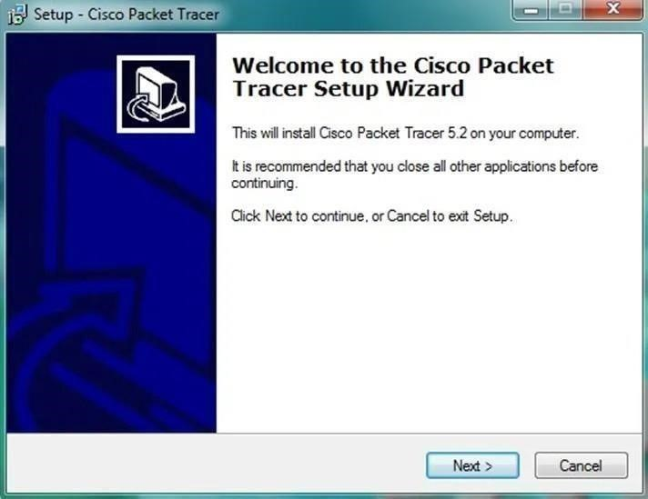

### STEP 2

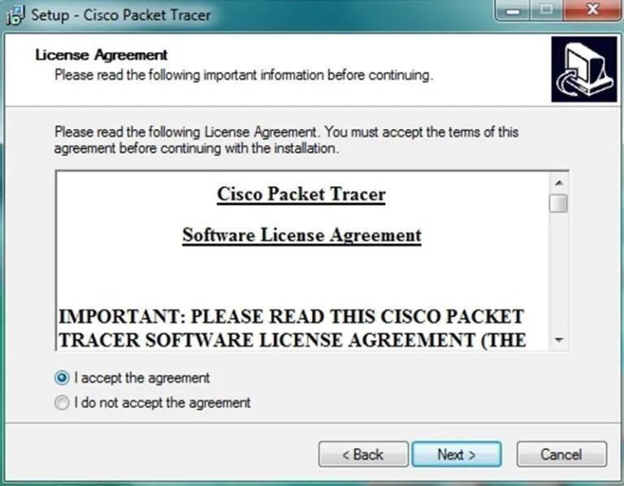

### STEP 3

Crozae a desIn

Create a Dt>ck

Late"+cm

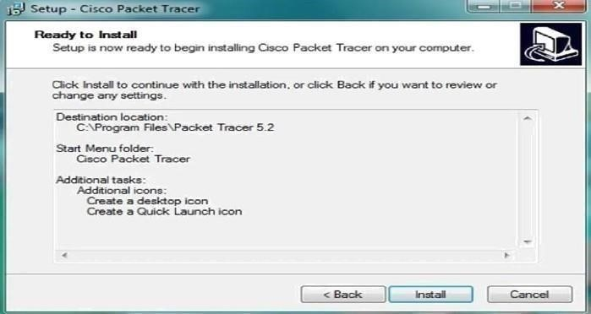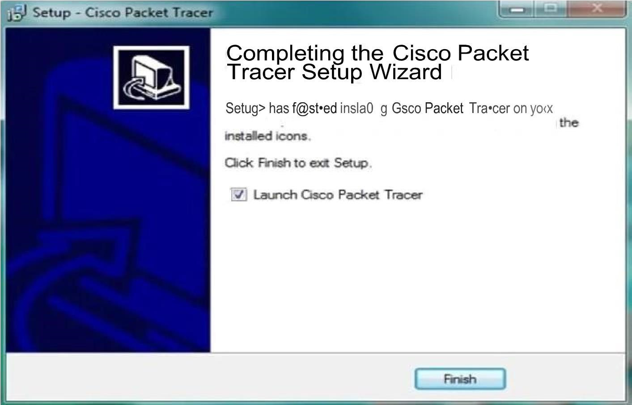

### Step 4 of installing packet tracer

Then the program will ask whether to create a Desktop icon and create a Quick Launch icon. Make your choice and click on “Next”.

### Step 5 of installing packet tracer

The summary of the settings we selected is displayed. Click on “Install”. Cisco packet tracer Installation gets completed and the below screen is shown. Click on “Finish”. Click “OK” on next popup asking you to close or restart your computer. Packet Tracer is installed and ready to be used.

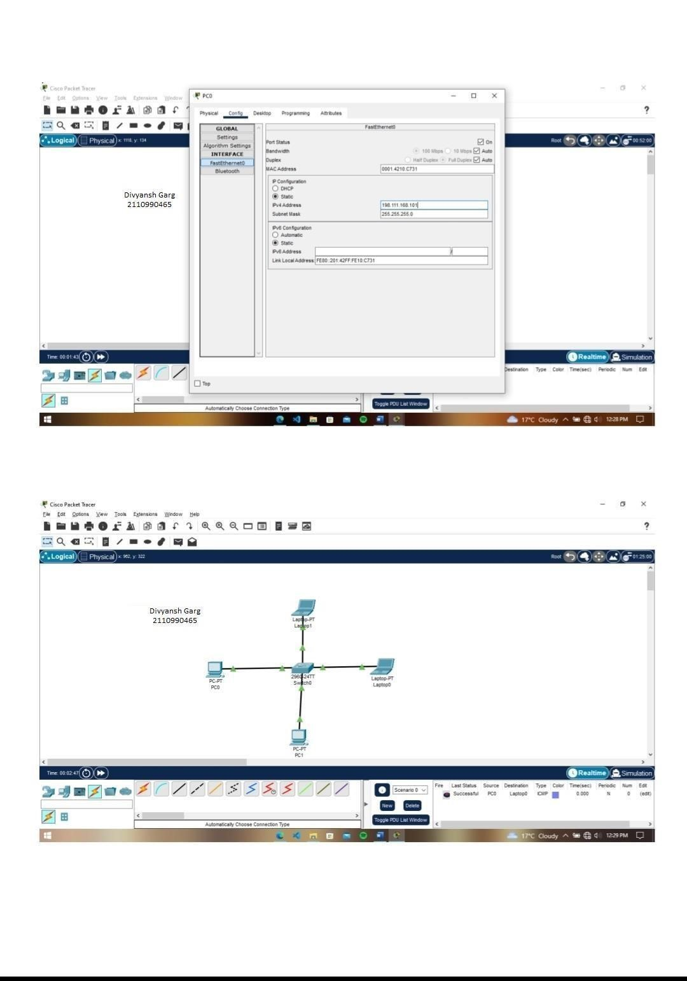

### Experiment No. 3

**Aim: - Simulation of Network Devices (HUB, Switches,**  **Router) and connect more than two computers using Switch to Topologies like Star, Mesh, Ring, BUS, Hybrid etc..**

Solution: - **Theory:**

#### Types of Topologies:-

1. Star Topology

2.Bus Topology

3.Tree Topology

4. Ring Topology

5.Mesh Topology

6.Hybrid Topology

##### 1. Star Topology :-

In star topology, all the devices are connected to a single hub through a cable. This hub is the central node and all other nodes are connected to the central node. The hub can be passive in nature i.e., not an intelligent hub such as broadcasting devices, at the same time the hub can be intelligent known as an active hub. Active hubs have repeaters in them. Coaxial cables or RJ-45 cables are used to connect the computers. In Star Topology, many popular Ethernet LAN protocols are used as CD(Collision Detection), CSMA (Carrier Sense Multiple Access), etc.





**2.**



**Bus Topology :**



**-**

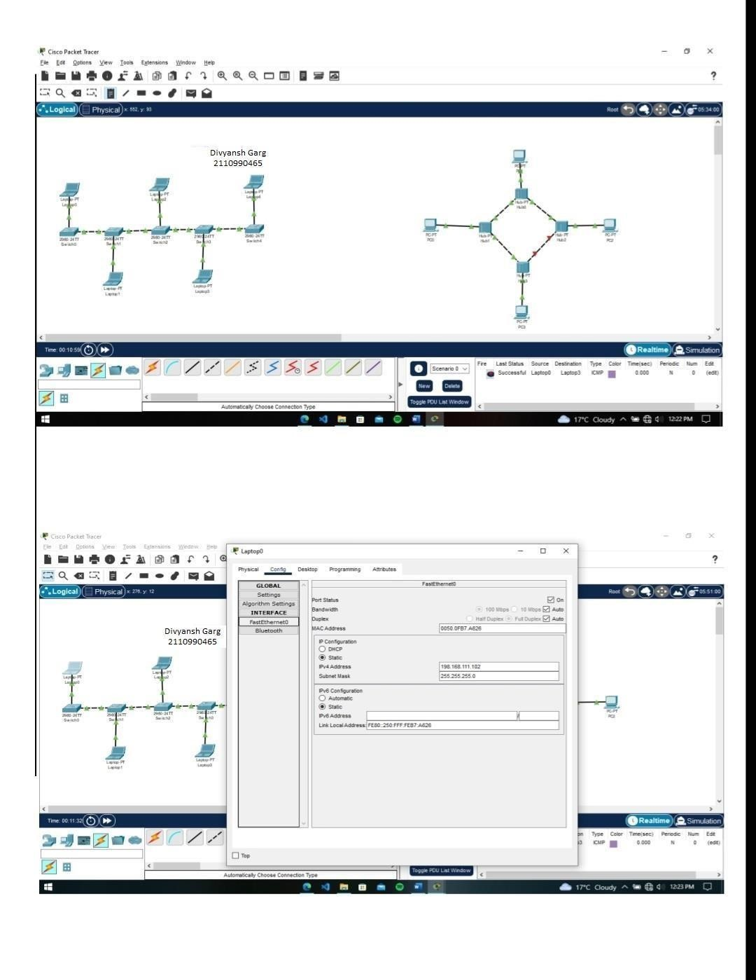

Bus topology is a network type in which every computer and network device is connected to a single cable. It is bi-directional. It is a multi- point connection and a non-robust topology because if the backbone fails the topology crashes. In Bus Topology, various MAC (Media Access Control) protocols are followed by LAN ethernet connections like TDMA, Pure Aloha, CDMA, Slotted Aloha, etc.

This topology is the variation of the Star topology. This topology has a hierarchical flow of data. In Tree Topology, protocols like DHCP and SAC (Standard Automatic Configuration ) are used.

#### 3.Ring Topology :-

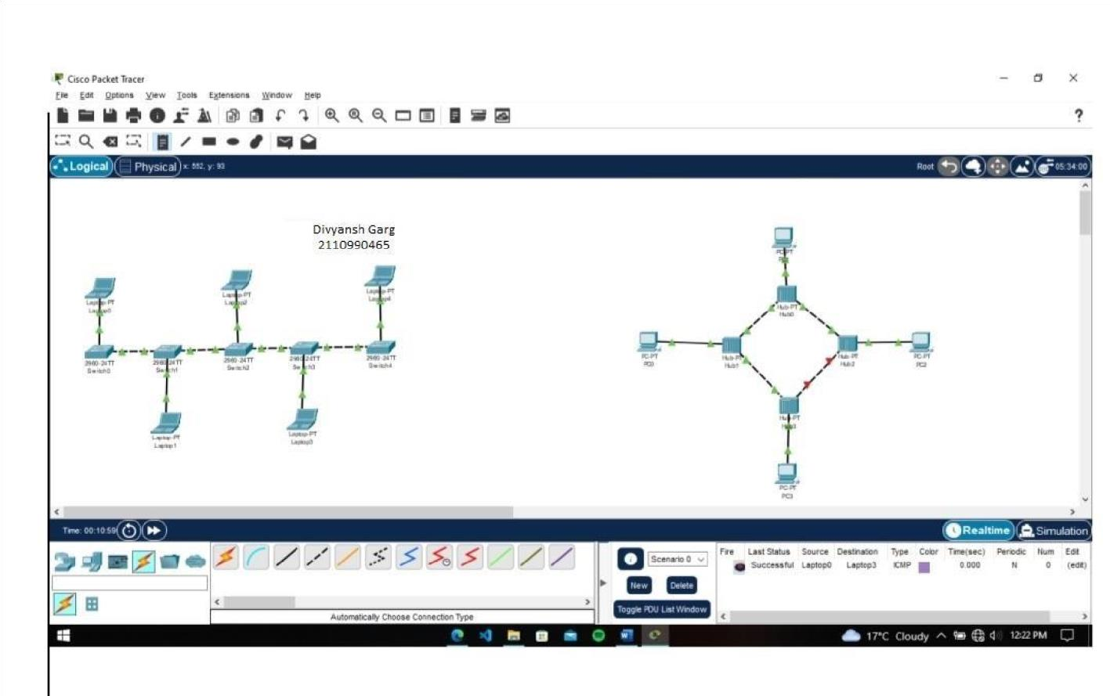

In this topology, it forms a ring connecting devices with exactly two neighbouring devices.

A number of repeaters are used for Ring topology with a large number of nodes, because if someone wants to send some data to the last node in the ring topology with 100 nodes, then the data will have to pass through 99 nodes to reach the 100th node. Hence to prevent data loss repeaters are used in the network.

The data flows in one direction, i.e.., it is unidirectional, but it can be made bidirectional by having 2 connections between each Network Node, it is called Dual Ring Topology. In-Ring Topology, the Token Ring Passing protocol is used by the workstations to transmit the data.

#### 4.Tree Topology :-

This topology is the variation of the Star topology. This topology has a hierarchical flow of data. In Tree Topology, protocols like DHCP and SAC (Standard Automatic Configuration ) are used.

##### 5. Mesh Topology :-

In a mesh topology, every device is connected to another device via a particular channel. In Mesh Topology, the protocols used are AHCP (Ad

Hoc

Configuration Protocols), DHCP (Dynamic Host Configuration Protocol), etc.

##### 6. Hybrid Topology :-

This topological technology is the combination of all the various types of topologies we have studied above. It is used when the nodes are free to take any form. It means these can be individuals such as Ring or Star topology or can be a combination of various types of topologies seen above. Each individual topology uses the protocol that has been discussed earlier.

**Experiment 4**

**AIM: Basic commands of Routers: hostname, password, Show Run, Show IP int brief, Assigning IP addresses to interfaces**

**Cisco Router basic commands:**

**1.hostname:**

To specify or modify the host name for the network server, use the **hostname** global configuration command. The host name is used in prompts and default configuration filenames. The **setup** command facility also prompts for a host name at startup.

##### hostname *name*

Syntax Description

|  |  |
| --- | --- |
| *name* | New host name for the network server. |

Defaults

The factory-assigned default host name is *router*.

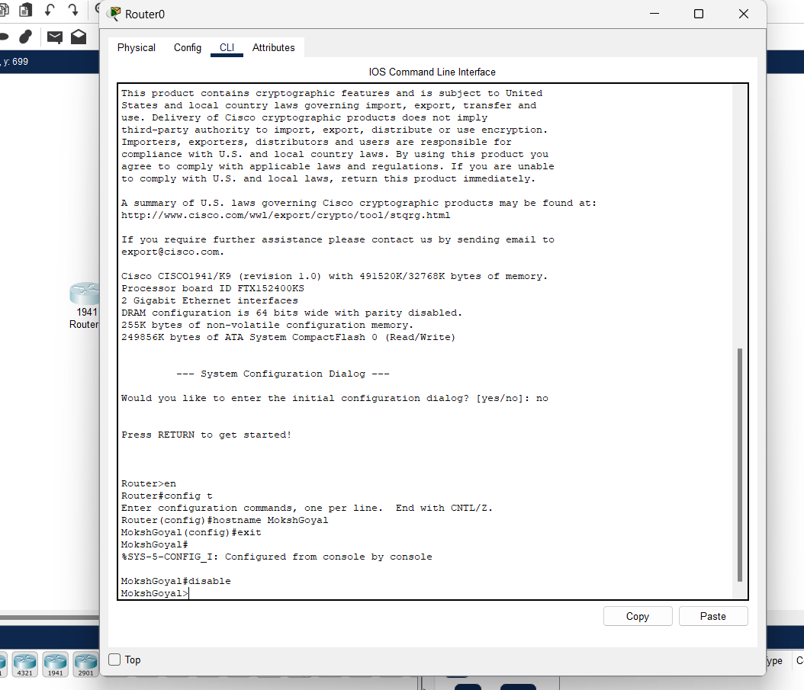

**2.Password:**

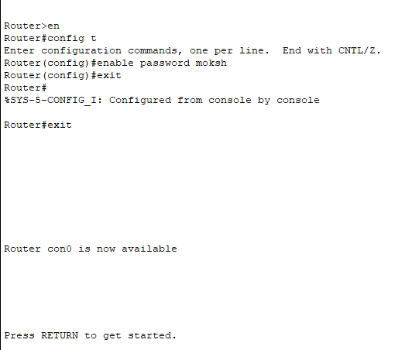

1. **Enblepassword :**The enable password is used for securing privilege mode. This password

will be shown in clear text by the command “show

runningconfiguration”. These are replaced by secret passwords nowadays.

router(config)#enable

password

2. **enable Secret password :**This is also used for securing privilege mode but the d the difference is that it will be displayed as a cipher in “show running-configuration”. This password will override the enable password if both passwords are set.

router(config)#enable secret

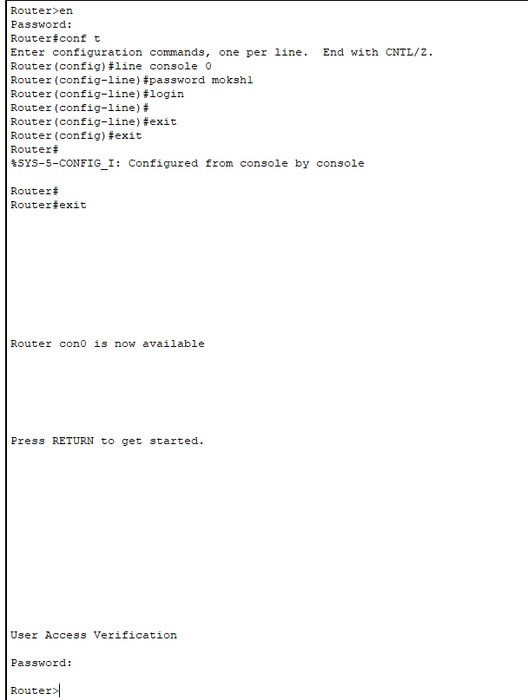**3. line console password –**

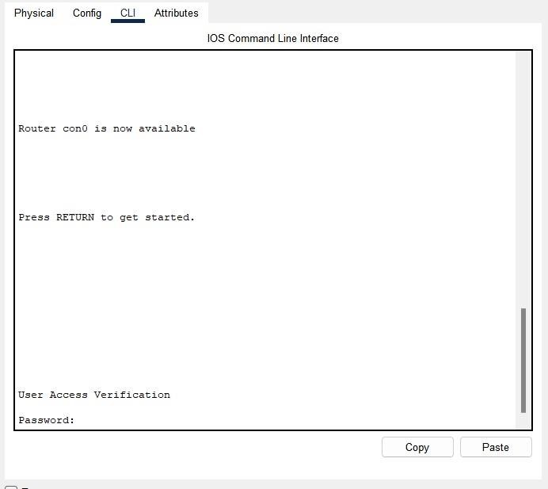

**3.Show Run:**

Type **"show run"** or **"show start"** to show the applicable config. The config will display without any breaks or pauses.

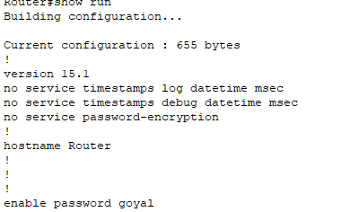

**4.show ip:**

To display IP configuration data, enter the show ip command in User Exec mode or Privileged Exec mode.

**show ip [address-table | route | http [server secure]]**

**Syntax Description**

|  |  |
| --- | --- |
| addresstable | (Optional) This keyword displays the address information  of  Ethernet interface ports, Ethernet interface cards, and InfiniBand interface cards. It lists the IP addresses, netmasks, broadcast formats, reassembly sizes, and whether or not the IP address is a primary or backup. |
| route | (Optional) This keyword displays the Classless InterDomain Routing (CIDR) forwarding records or routes (both static and dynamic) of all IP routes to system ports. Included in this information are the route destination, route type, route protocol, next hop, and port used. |
| http | (Optional) Displays current HTTP settings. |
| server secure | (Optional) Displays current secure HTTP server settings. |

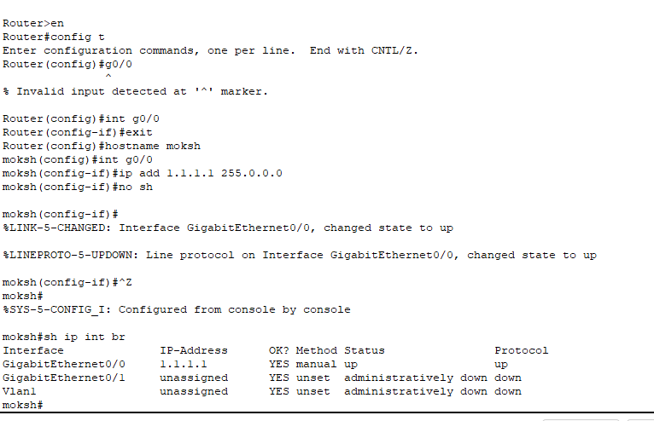

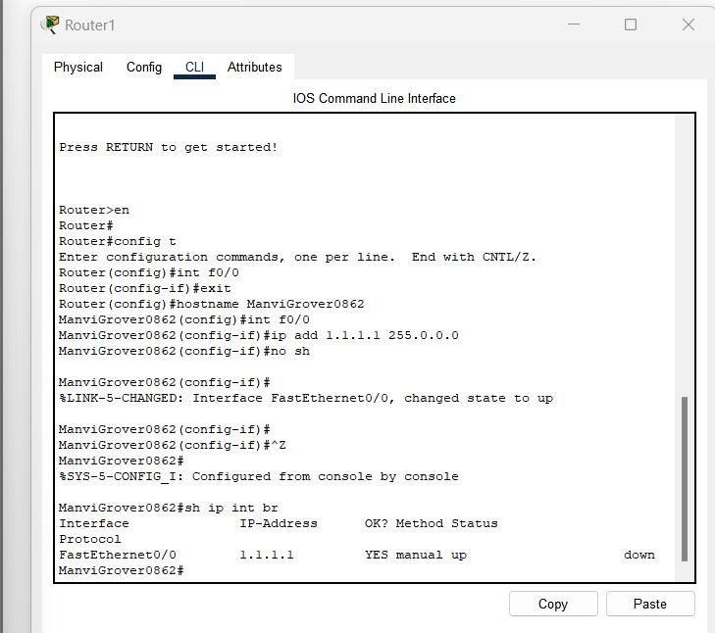

**5.AssigningIPaddressestointerfaces:**

*Assign an IP address to that interface with the 'ip address' command followed by the IP address and the subnet mask for that interface. Run the 'show IP interface brief' command again to verify the IP address has been assigned to the network interface*





##### EXPERIMENT 5

**AIM: To do peer to peer connectivity, assign the IP address and share the resources.**

Step1: Take Two end devices and connects them using Copper Cross Over Wire

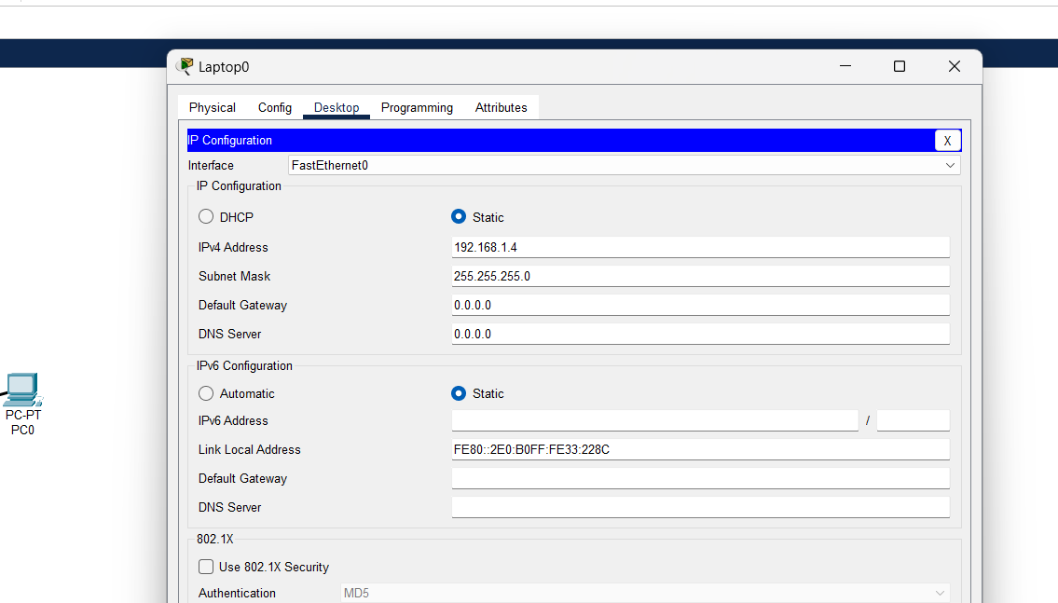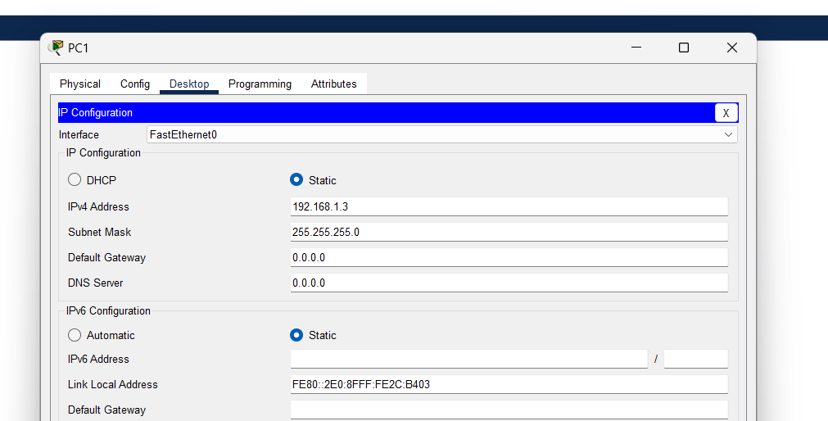Step2: In Dektop , Change their IPv4 Address .

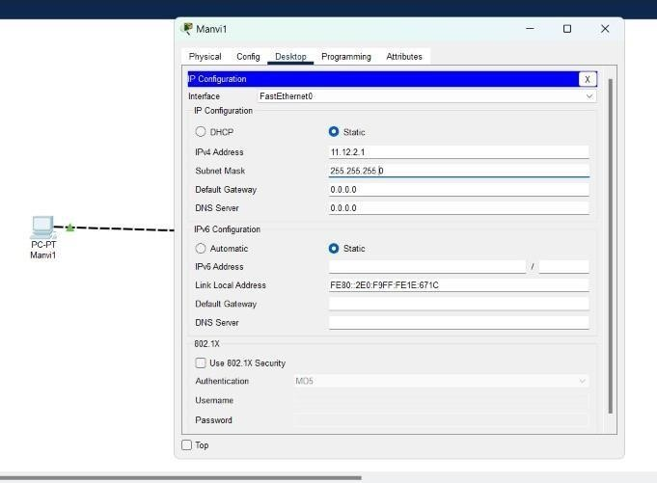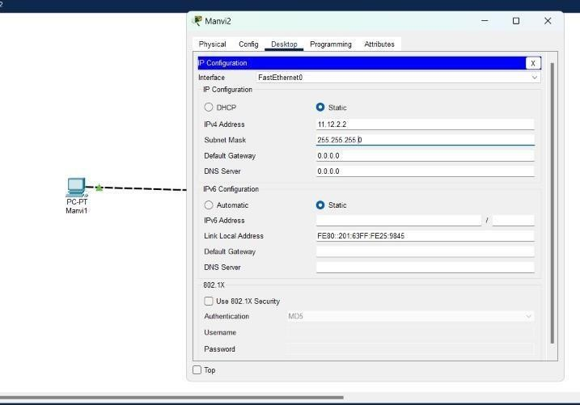

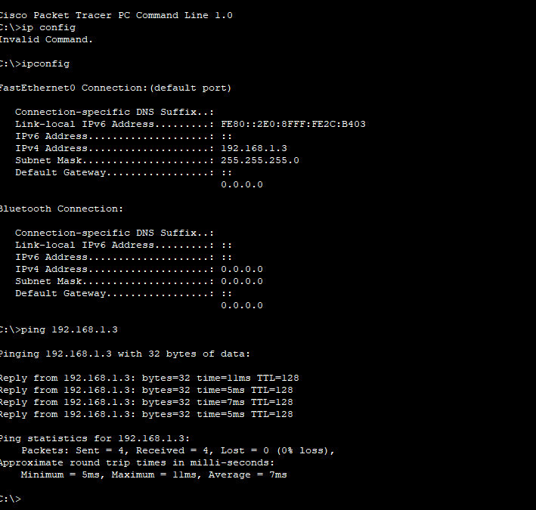Step3: In Desktop Command Prompt use Commands IpConfig and ping to check is it working properly.



Step 4: Do this Same with Second end Device.

Step 5: Now Send the message from Laptop0 (i.e) Laptop0 to PC1.

Step 6: Click on Simulation and play the Simulation. We can see that

Message is sending from PC1 to Laptop0. And Its is Showing a Successful Status.

